REPORTS FROM JIRA

|  |  |
| --- | --- |
| Team ID | PNT2022TMID45387 |
| Project Name | Project-Gas leakage monitoring and alerting system for industries |

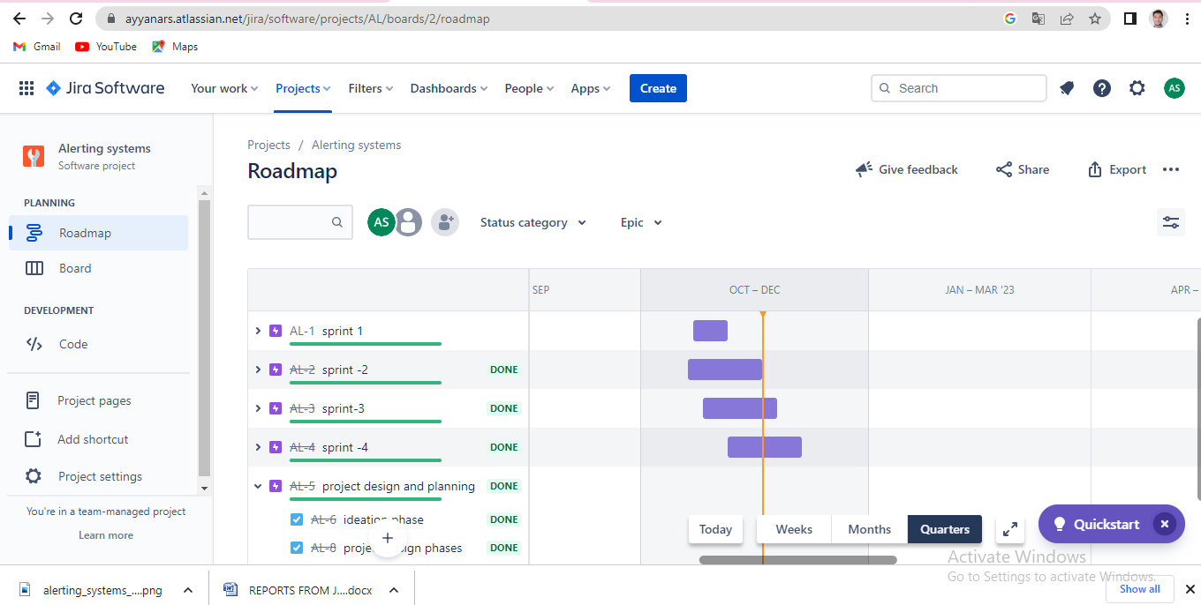

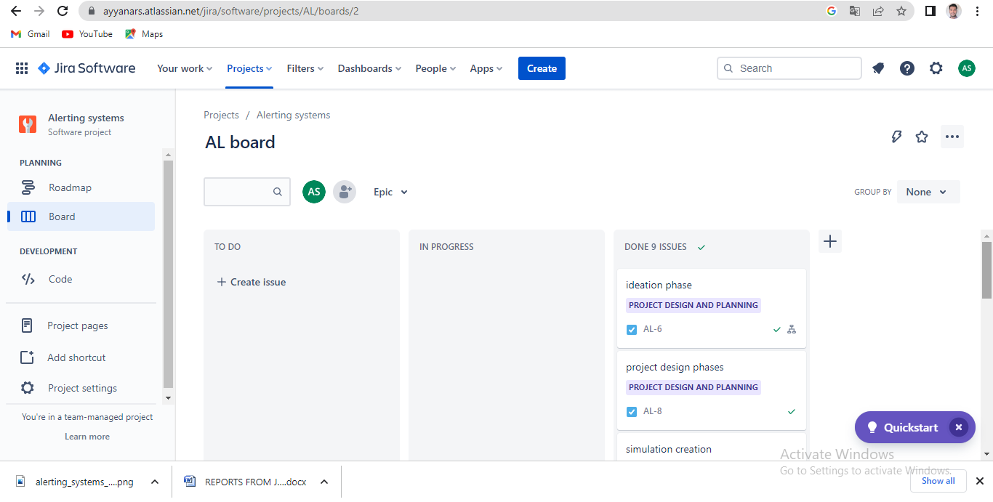

Link:<https://ayyanars.atlassian.net/jira/software/projects/AL/boards/2>